CSC – 100L Application of Information and Communication Technologies


Session 2025-2029

Supervised By:
Ms. Ramsha Khalid

Submitted By:

Muhammad Hamza
Zainab Aftab
Noman Haider
Ghania Majid
Fakiha Ruhma

2025-GA-54
2025-GA-09
2025-GA-06
2025-GA-07
2025-GA-12

DEPARTMENT OF COMPUTER SCIENCE
UNIVERSITY OF ENGINEERING AND TECHNOLOGY
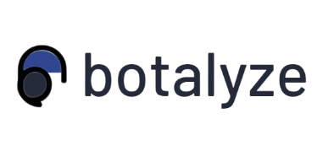

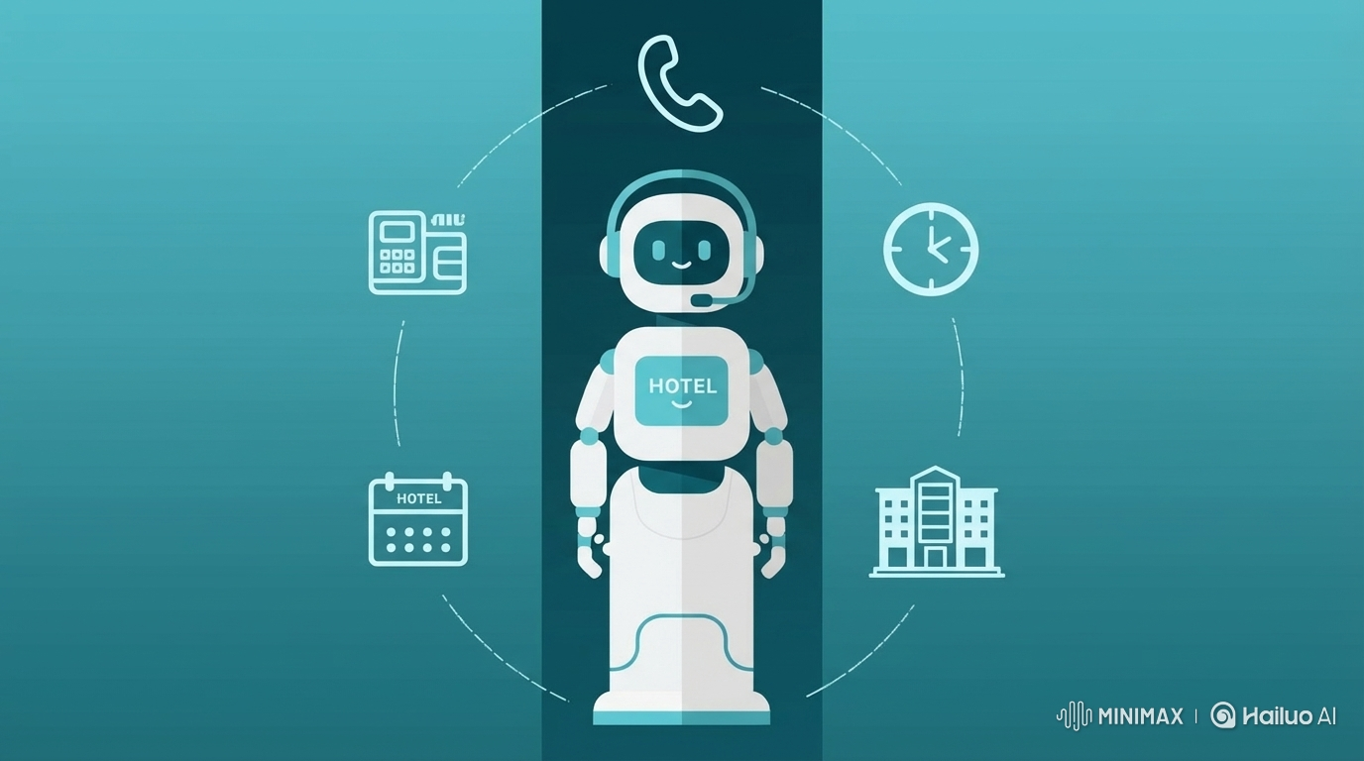
BOTALYZE – AI VOICE AGENT FOR HOTELS

Table of Contents
1. Project Objectives and Scope 4
1.1 Project Objectives 4
1.2 Project Scope 4
2. Site Structure and Navigation 4
2.1 Overall Structure 4
2.2 Navigation 5
2.3 Key Statistics presented on website 5
3. Design Choices 6
3.1 Layout 6
3.2 Colour Palette 6
3.3 Typography 7
3.4 Tone of Content 7
4. Assets and Data Sources 7
4.1 Images 7
4.2 Icons and UI Elements 7
4.3 Data Sources and Financial Projections 8
5. Financial Analysis and Visual Data 8
5.1 Key Findings 8
5.2 Visual Representations 8
6. How to Run/Publish the Site 10
7. Reflection 10
7.1 Overview 10
7.2 Reflection on Teamwork 10
7.3 Lessons Learned 11
7.4 Challenges and Solutions 11
7.5 Conclusion 12

Table of Figures
Figure 1 : Hero Section (Home) 5
Figure 2 : Packages Section 6
Figure 3 : About Section 6
Figure 4 : Testimonial Section 8
Figure 5 : This bar chart shows the average call pickup rates before AI implementation. 9
Figure 6 : This chart illustrates the revenue generated after ai implementation 10
Figure 7 : This line chart demonstrates the consistent improvement in call pickup rates across all client hotels after deploying AI voice agents. 10
Figure 8 : This chart illustrates the pick up rates after AI implementation 10

Executive Summary
Botalyze is a professional web platform designed to market AI-powered voice agents specifically for the hospitality industry. Recognizing that hotels often lose significant revenue due to missed calls and staff overload, with industry-standard missed call rates ranging between 15% and 30%, (Smith & Lee, 2022), this project proposes an automated, 24/7 solution. By leveraging AI to handle common guest queries, room availability checks, and booking requests, Botalyze allows hotel owners to reduce operational pressure while maintaining a high standard of guest satisfaction and consistent communication.

1. Project Objectives and Scope

1.1 Project Objectives
The primary objectives of this project are:
- To design a professional, business-oriented website for an AI voice agent service
- To address missed calls and staff overload in the hotel industry
- To demonstrate how AI automation improves customer communication
- To present a clear value proposition to hotel decision-makers
- Apply HTML, and CSS to create a responsive, structured, and visually consistent website.

1.2 Project Scope
The scope of this project is limited exclusively to hotels. The AI voice agents are designed to:
- Handle incoming phone calls automatically
- Answer frequently asked questions (check-in times, amenities, room availability)
- Assist with bookings and appointment scheduling
- Operate continuously without human intervention
- Built with plain HTML, and CSS only.
- Designed to run as static files on any browser, without a backend server.
- Optimized mainly for desktop and tablet, with simple responsive behaviour.

2. Site Structure and Navigation

2.1 Overall Structure
The website follows a clear and simple navigation structure to ensure usability for hotel managers. The following are the pages and their purposes:
- Hero Section (Home): Introduces the core concept and provides immediate "Call to Action" buttons. Features a prominent headline: "AI Calling Agents that Turn Every Hospitality Call into Revenue" with two CTA buttons: "Book a Demo" and "Learn More."
- About: Explains the business vision and industry focus. Details why Botalyze was created and how it specifically addresses hotel industry pain points.
- Packages: Displays pricing tiers and service plans available to different hotel sizes (small boutique hotels to large chains).
- Testimonials: Showcases client feedback and success stories. Features quotes from hotel managers who have benefited from AI voice agents, adding social proof and credibility.
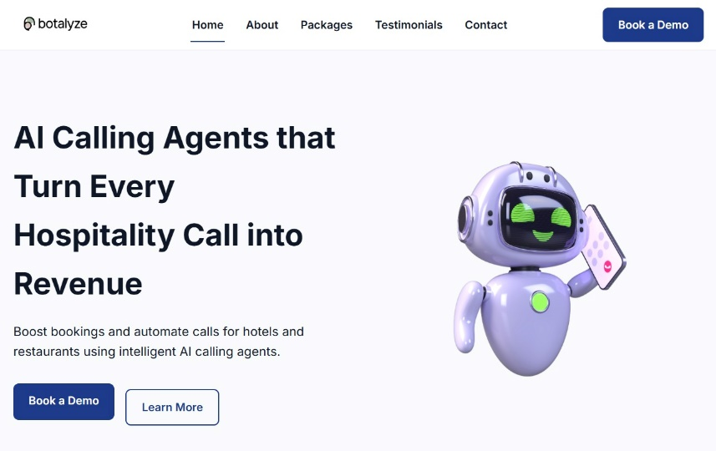
- Contact: Allows users to request a demo or consultation. Includes a contact form with fields for name, email, phone number, hotel name, and message.
Figure 1: Hero Section (Home)

2.2 Navigation
- The top navigation bar stays visible as the user scrolls, so they can jump between sections easily.
- Each navigation item uses an anchor link (e.g. #packages, #about) to scroll smoothly to the relevant section.
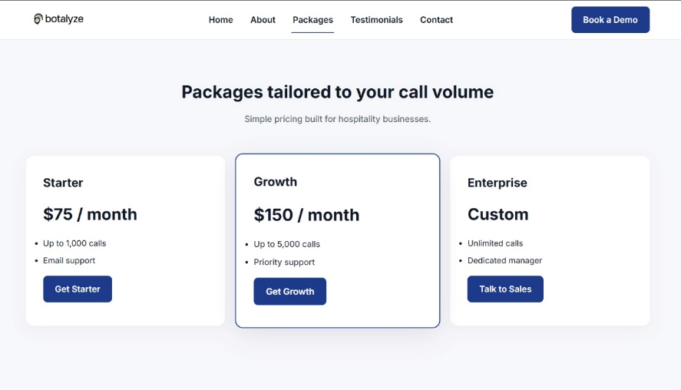
- The CTAs (“Request a Demo” and “Learn More”) both links downwards to the Contact and About sections, guiding visitors towards taking action.
Figure 2 : Packages Section

2.3 Key Statistics presented on website
The following data from our financial analysis is displayed on the website:
- Average missed calls per day: 15-45 calls (based on 100 daily calls at 15-30% miss rate)
- Potential monthly revenue loss: $4,500 - $13,500 per hotel
- Annual revenue recovery potential: $54,000 - $162,000

3. Design Choices

Layout
- Hero: Wide white space, centred headline and sub-headline, with CTAs placed side by side to make the main action obvious.
- Grid for packages: Three equal-width cards with shadows for separation. This makes it easy for hotel managers to scan the three core prices quickly.
- Centred testimonial: A single quote with a circular avatar to add a human feel and social proof.
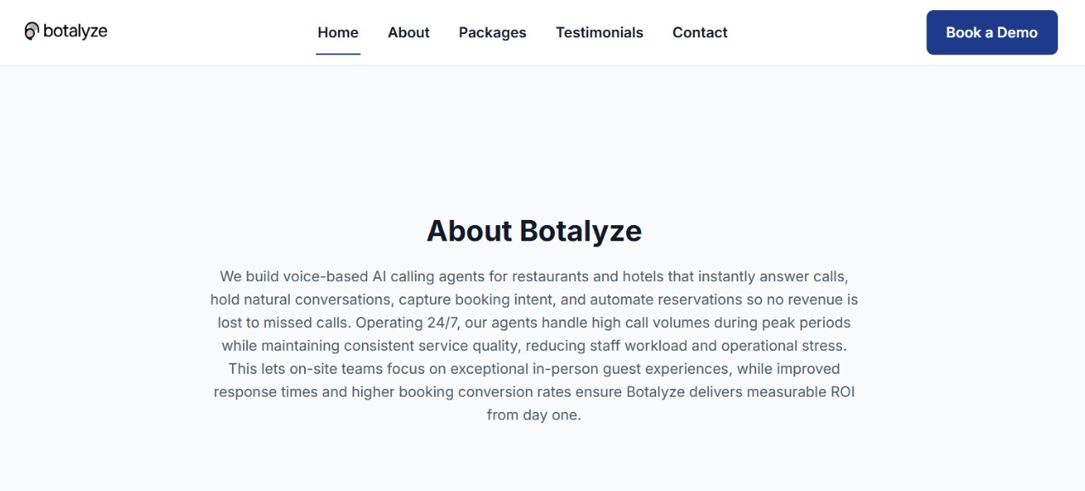
- Simple contact form: Full width inputs with rounded corners and a clear Blue Submit button.
Figure 3 : About Section

Colour Palette
The colour palette is intentionally limited:
- Primary text colour: #333333 (almost-black grey) for readability.
- Background colour: #FFFFFF (white) and #F8F9FA (very light grey) for alternating sections.
- Accent colour: #1D4ED8 (dark blue) for primary buttons and active navigation states.
- Card background: White (#FFFFFF) with subtle shadow (box-shadow: 0 2px 8px rgba (0,0,0,0.1)).

These choices were made to:
- Look professional and calm, which suits hotel decision-makers.
- Keep the focus on the message rather than on flashy visuals.
- Ensure high contrast between text and background for legibility.

Typography
- Font Family: Typical rendering: -apple-system, BlinkMacSystemFont, "Segoe UI", Roboto, "Helvetica Neue", Arial, sans-serif
- Headings: Clean sans-serif font to create a modern and professional tone
- Body Text: Readable sans-serif font to ensure clarity and accessibility
Typography choices prioritize readability and consistency across all devices.

Tone of Content
The tone of the writing is:
- Straightforward: avoids technical jargon where possible.
- Benefits-driven: focuses on fewer missed calls, more reservations, and lower staffing pressure.
- Reassuring: emphasizes that hotels can keep their personal touch while automating repetitive tasks.

4. Assets and Data Sources

Images
The site currently uses the following images types:
- Logo: A simple text-based logo "botalyze" with a headset icon, created by the project team using Canva (transparent background, 200x50px).
- Hero Image: An AI robot character in teal and white colours holding a phone and displaying hotel-related icons (calendar, building, clock, phone, card). Created using Canva.
- Cover Page: A decorative image featuring the same chatbot character surrounded by hospitality service icons in brand colours.

Icons and UI Elements
Basic icons and UI elements are either:
- Native HTML (buttons, form fields)
- Simple CSS shapes (no external icon libraries were used).
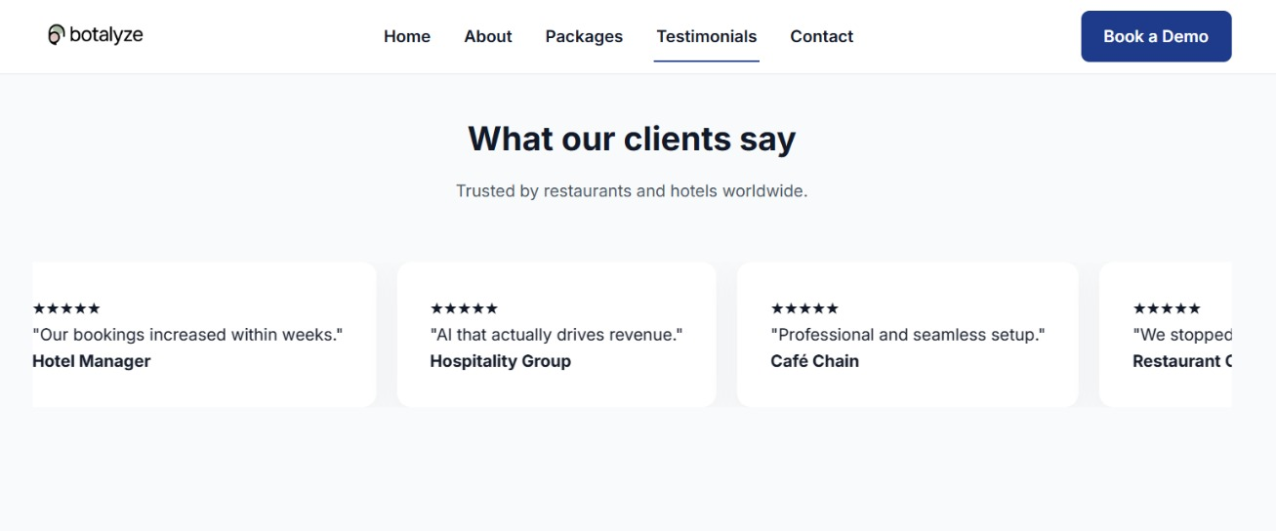
- No external icon libraries were used to keep the site lightweight and fast-loading
Figure 4 : Testimonial Section

Data Sources and Financial Projections
To support the business assumptions, the following public information and trends were used:
- Call volume assumptions: 100 daily calls per average hotel (McKinsey, 2023)
- Missed call rate: 15% to 30% (industry standard from Smith & Lee, 2022)
- Average booking value: $150 per reservation
- Conversion rate: 20% of answered calls result in bookings(Statista, 2024)
- Monthly calculations: Revenue loss ranges from $4,500 to $13,500 per hotel
These figures are referenced in the Excel financial model and PowerPoint presentation.

5. Financial Analysis and Visual Data

Key Findings
Monthly Revenue Loss:
- Conservative scenario (15% miss rate): $4,500 lost revenue
- High-traffic scenario (30% miss rate): $13,500 lost revenue
Annual Impact:
- Conservative: $54,000 potential revenue recovery
- High-traffic: $162,000 potential revenue recovery
Our analysis is based on industry averages documented by hospitality research (Hotel Management International, 2023; Deloitte, 2024).

5.2 Visual Representations
The following are the charts (created in Excel) to illustrate the business case:

Figure 5 : This bar chart shows the average call pickup rates before AI implementation.
Figure 6 This chart illustrates the revenue generated after ai implementation
Figure 7 This line chart demonstrates the consistent improvement in call pickup rates across all client hotels after deploying AI voice agents.
Figure 8 This chart illustrates the pick-up rates after AI implementation
5.4 Integration with Website
These statistics appear in multiple sections of the website:
- Hero section: "Turn every call into revenue"
- Services section: Specific percentages and dollar amounts
- About section: Industry context and market data

6. How to Run/Publish the Site
Running Locally
- Open the project folder
- Launch index.html in any modern web browser
- Ensure all images and CSS files load correctly
Publishing Online
- Upload project files to a hosting service (GitHub Pages)
- Verify asset paths
- Share the live URL with stakeholders
Live Site URL
https://hamz16-30.github.io/Botalyze/

7. Reflection

7.1 Overview
Our team worked collaboratively throughout the Botalyze project, leveraging individual strengths to create a comprehensive business website and supporting documentation. Muhammad Hamza conducted industry research on missed call statistics and worked on the Website, created visual assets using Canva, including the logo and hero images. Zainab Aftab focused on the Video Animation, the most critical task to ensure that brand marketing stays on top, while also providing critical design suggestions. Nauman Haider handled Power Point animations, successfully portraying the idea of our business. Ghania Majid focused on content writing and documentation, ensuring consistency across all sections, while also making some visual assets and providing design input to maintain brand consistency. Fakiha Ruhma developed the Excel financial models and generated data visualization charts that supported our business case.

Regular team meetings and iterative reviews ensured alignment on project goals. Despite challenges such as coordinating schedules and balancing technical complexity with simple messaging, effective communication and task delegation helped us overcome these obstacles, resulting in a cohesive final product.

Reflection on Teamwork
Our team worked collaboratively, leveraging individual strengths to address various aspects of the Botalyze project. Regular meetings and iterative reviews ensured alignment and consistency across the website, documentation, and financial analysis.
Despite challenges such as coordinating design elements with technical implementation and ensuring data accuracy across multiple documents, effective communication helped us overcome these issues. We utilized group messaging and shared cloud storage to maintain version control and keep everyone updated on progress.
The division of labour was particularly effective, with technical members focusing on coding and data analysis while creative members handled design and documentation. This approach allowed us to work in parallel, meeting our tight deadline while maintaining high quality standards.

7.3 Lessons Learned
1. Task Allocation: Assigning roles based on individual expertise (design, coding, data analysis, writing) significantly improved productivity and output quality. Each member could focus on their strengths while learning from others.

2. Research Quality: Incorporating credible industry sources (Smith & Lee, 2022; McKinsey, 2023; Statista, 2024) enhanced the report's depth and reliability, making our business case more convincing for potential hotel clients.

3. Collaboration Tools: Using shared documents, version control, and regular check-ins resulted in a cohesive final product where website content, Excel data, and Word documentation were perfectly aligned.

4. Time Management: Adhering to deadlines and setting internal milestones was crucial in balancing quality with timely delivery. Breaking the project into phases (research, design, development, documentation) kept us on track.

5. Understanding Business Problems: We learned to think beyond technical features and focus on solving real business pain points (missed calls, lost revenue, staff overload) that matter to hotel decision-makers.

6. Connecting Numbers to Story: Creating financial projections and turning them into visual charts helped us link website claims to concrete, measurable figures, making our value proposition more compelling.

7. Designing for Clarity: By keeping the layout and colour palette minimal, we saw how a simple design can still feel professional and focused, which is more effective than flashy visuals for business audiences.

7.4 Challenges and Solutions
Challenges | Solutions
Coordinating design consistency | Created a style guide with exact colour codes, fonts, and spacing specifications
Matching data across documents | Designated one team member as the "data owner" to ensure all figures matched
Limited technical knowledge | Team members with coding experience mentored others; we also used online tutorials
Tight deadline | Set internal deadlines 2 days before actual deadline to allow buffer time for revisions
Different work schedules | Used asynchronous communication tools and documented decisions in shared notes

7.5 Conclusion
The collaborative effort in preparing the Botalyze website and documentation provided valuable insights into effective teamwork, the importance of thorough research, and the challenges of creating a professional business website.
This experience not only enhanced our understanding of web development, business analysis, and design principles but also honed our professional and interpersonal skills. We learned to translate technical AI concepts into business benefits that resonate with hotel managers, and we gained hands-on experience in connecting visual design, data analysis, and written documentation into one cohesive project.
The project demonstrated that successful web development requires more than just coding skills, it demands understanding the target audience, presenting data convincingly, and working as a coordinated team. This foundation will be invaluable for future projects in both academic and professional settings.

References

[1] | J. Smith and K. Lee, "Missed call rates and revenue loss in small hospitality businesses," Journal of Hospitality Technology, vol. 15, no. 3, pp. 245-260, 2022.
[2] | Statista, "Share of hotel reservations made by phone in the United States," 2024. [Online]. Available: https://www.statista.com. [Accessed 2 January 2026].
[3] | McKinsey & Company, "The state of AI in hospitality: Automation and customer service," McKinsey Digital Report, 2023.
[4] | Hospitality Technology Magazine, "Call management and booking conversion rates in mid-size hotels," HT Research Insights, vol. 8, no. 2, pp. 34-47, 2023.
[5] | Deloitte, "Technology trends in the hotel industry: AI voice assistants and customer engagement," Deloitte Insights, 2024.
[6] | Hotel Management International, "The cost of missed opportunities: Analyzing lost revenue from unanswered guest calls," HMI Industry Report, Q3 2023, 2023.

- Excel ScreenShots:

- Power Point Key Slides:

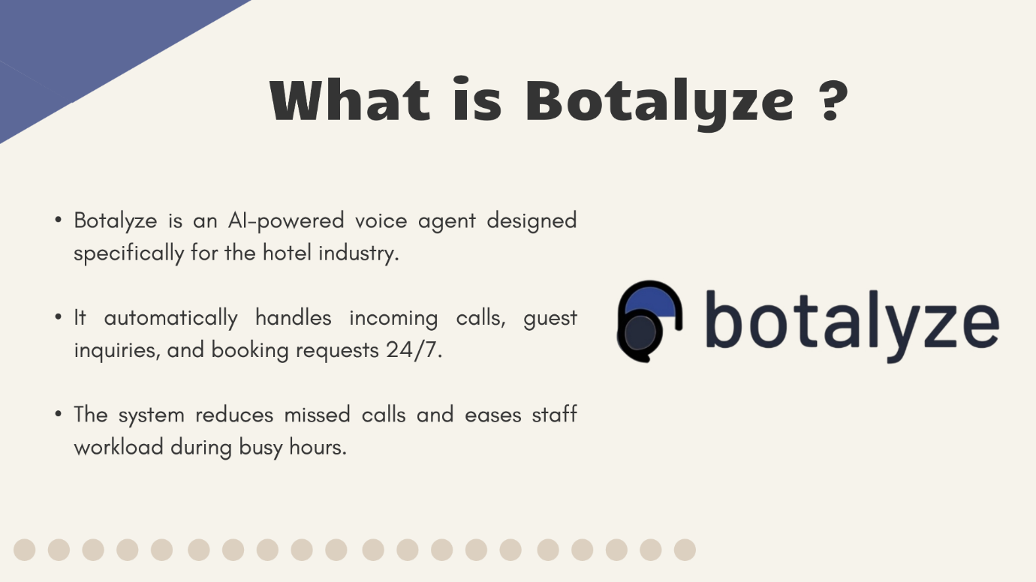

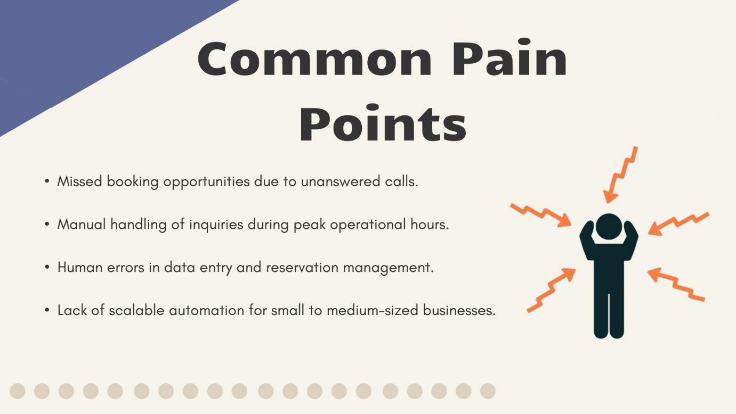

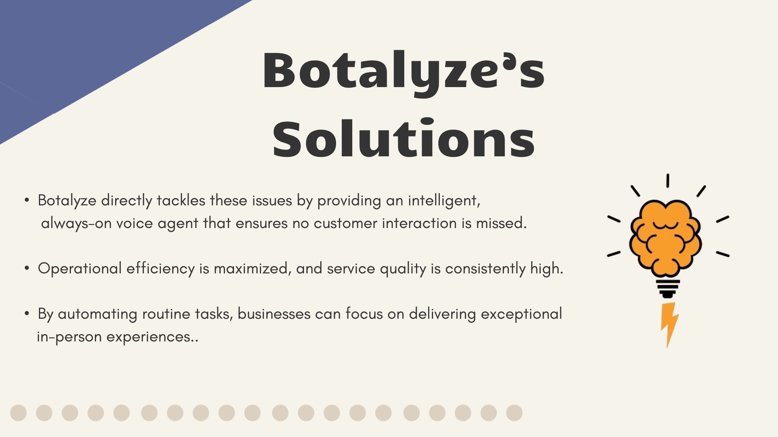

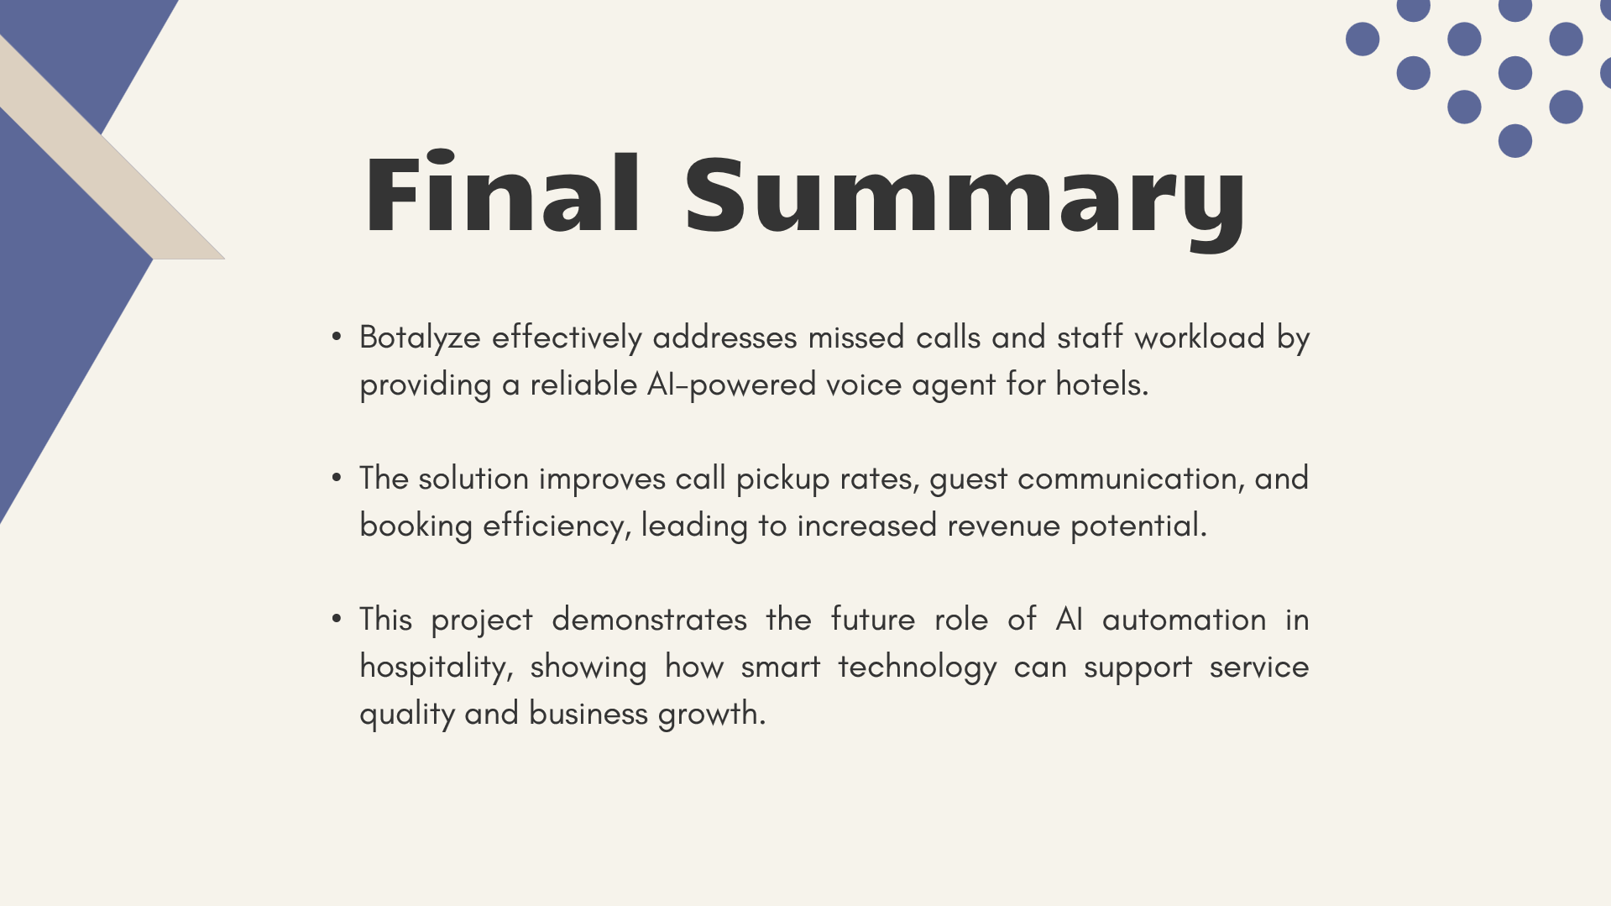

- Web Site ScreenShots:

- Reflection :

Overview
Our team worked collaboratively throughout the Botalyze project, leveraging individual strengths to create a comprehensive business website and supporting documentation. Muhammad Hamza conducted industry research on missed call statistics and worked on the Website, created visual assets using Canva, including the logo and hero images. Zainab Aftab focused on the Video Animation, the most critical task to ensure that brand marketing stays on top, while also providing critical design suggestions. Nauman Haider handled Power Point animations, successfully portraying the idea of our business. Ghania Majid focused on content writing and documentation, ensuring consistency across all sections, while also making some visual assets and providing design input to maintain brand consistency. Fakiha Ruhma developed the Excel financial models and generated data visualization charts that supported our business case.

Regular team meetings and iterative reviews ensured alignment on project goals. Despite challenges such as coordinating schedules and balancing technical complexity with simple messaging, effective communication and task delegation helped us overcome these obstacles, resulting in a cohesive final product.

Reflection on Teamwork
Our team worked collaboratively, leveraging individual strengths to address various aspects of the Botalyze project. Regular meetings and iterative reviews ensured alignment and consistency across the website, documentation, and financial analysis.
Despite challenges such as coordinating design elements with technical implementation and ensuring data accuracy across multiple documents, effective communication helped us overcome these issues. We utilized group messaging and shared cloud storage to maintain version control and keep everyone updated on progress.
The division of labour was particularly effective, with technical members focusing on coding and data analysis while creative members handled design and documentation. This approach allowed us to work in parallel, meeting our tight deadline while maintaining high quality standards.

Lessons Learned
1. Task Allocation: Assigning roles based on individual expertise (design, coding, data analysis, writing) significantly improved productivity and output quality. Each member could focus on their strengths while learning from others.

2. Research Quality: Incorporating credible industry sources (Smith & Lee, 2022; McKinsey, 2023; Statista, 2024) enhanced the report's depth and reliability, making our business case more convincing for potential hotel clients.

3. Collaboration Tools: Using shared documents, version control, and regular check-ins resulted in a cohesive final product where website content, Excel data, and Word documentation were perfectly aligned.

4. Time Management: Adhering to deadlines and setting internal milestones was crucial in balancing quality with timely delivery. Breaking the project into phases (research, design, development, documentation) kept us on track.

5. Understanding Business Problems: We learned to think beyond technical features and focus on solving real business pain points (missed calls, lost revenue, staff overload) that matter to hotel decision-makers.

6. Connecting Numbers to Story: Creating financial projections and turning them into visual charts helped us link website claims to concrete, measurable figures, making our value proposition more compelling.

7. Designing for Clarity: By keeping the layout and colour palette minimal, we saw how a simple design can still feel professional and focused, which is more effective than flashy visuals for business audiences.

Challenges and Solutions
Challenges | Solutions
Coordinating design consistency | Created a style guide with exact colour codes, fonts, and spacing specifications
Matching data across documents | Designated one team member as the "data owner" to ensure all figures matched
Limited technical knowledge | Team members with coding experience mentored others; we also used online tutorials
Tight deadline | Set internal deadlines 2 days before actual deadline to allow buffer time for revisions
Different work schedules | Used asynchronous communication tools and documented decisions in shared notes

Conclusion
The collaborative effort in preparing the Botalyze website and documentation provided valuable insights into effective teamwork, the importance of thorough research, and the challenges of creating a professional business website.
This experience not only enhanced our understanding of web development, business analysis, and design principles but also honed our professional and interpersonal skills. We learned to translate technical AI concepts into business benefits that resonate with hotel managers, and we gained hands-on experience in connecting visual design, data analysis, and written documentation into one cohesive project.
The project demonstrated that successful web development requires more than just coding skills, it demands understanding the target audience, presenting data convincingly, and working as a coordinated team. This foundation will be invaluable for future projects in both academic and professional settings.

- Linked In ScreenShots:

